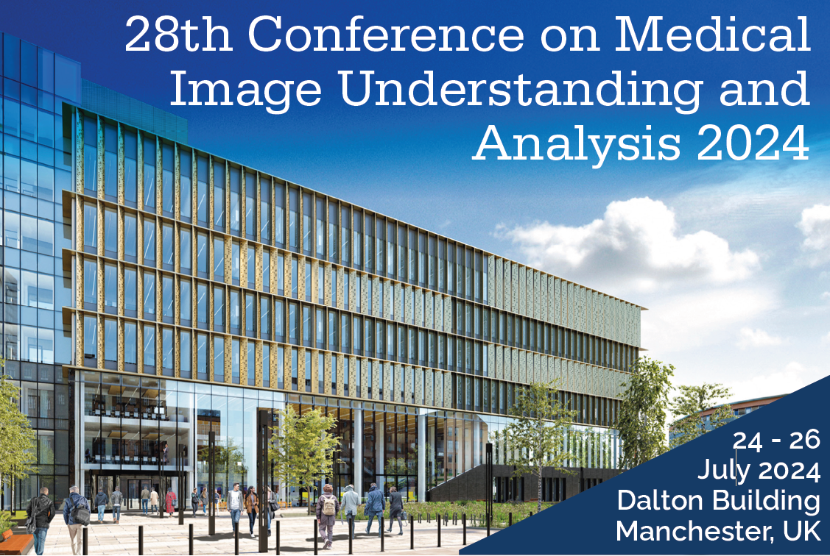

**Call for Special Session Proposals**

MIUA 2024 is the principal UK conference for research in image analysis related to medicine and allied sciences including computer scientists, bioinformaticians, mathematicians, clinicians, engineers and bioscientists. We are looking for proposals for Special Sessions to shape the direction of this conference. Special sessions provide an opportunity to address:

* Emerging areas and hot topics that grant a focused discussion on new and innovative aspects.
* Or additional topics which are not directly listed by the conference topics;

Please use this template to submit your proposal.

**Important Information**

**8th January 2024:** Deadline for submissions of special session proposals  
**15th January 2024:** Notification of acceptance  
**24-26th July 2024:** Conference days

As is the case for regular papers, the submission deadline for special session papers is **April 8, 2024**. These papers will undergo the same peer review and decision process as all other MIUA regular papers and, if accepted, will be published in the proceedings. If the special session does not have sufficient number of papers accepted, then the special session may be cancelled, and the accepted papers submitted to the special session would be shared with other regular sessions in the area.

**Contact** **Information**

For any enquiries concerning MIUA Special Sessions, please contact the Special Sessions Committee on [***miua2024@mmu.ac.uk***](mailto:miua2024@mmu.ac.uk)